Compolsory Assignment

Dataset
The dataset I have chosen is a dataset on student performance which includes 5000 records. The dataset was found on Kaggle and can be found here: https://www.kaggle.com/datasets/suvidyasonawane/student-performance-dataset

Features
Student_ID: A unique identification number for each student.
Age: The age of the student.
Gender: The gender of the student.
Class: The student's class or academic group.
Study_Hours_Per_Day: The average number of hours the student studies per day.
Attendance_Percentage: The percentage of classes attended by the student.
Parental_Education: The education level of the student's parents.
Internet_Access: Whether the student has access to the internet.
Extracurricular_Activities: Whether the student participates in extracurricular activities.
Math_Score: The student's score in mathematics.
Science_Score: The student's score in science.
English_Score: The student's score in English.
Previous_Year_Score: The student's score from the previous academic year.
Final_Percentage: The student's final overall percentage.
Performance_Level: The student's overall performance category.
Pass_Fail: Whether the student passed or failed.

Tasks

Task 1 - Plot the average Final Percentage against Study Hours Per Day.
Task 2 - Create a scatter plot to visualize Attendance Percentage vs. Final Percentage.
Task 3 - Create a bar chart comparing the average Math, Science and English scores.
Task 4 - Create a scatter plot to visualize Previous Year Score vs. Final Percentage.
Task 5 - Create a scatter plot of Study Hours Per Day vs. Final Percentage, differentiating students by Gender.
Task 6 - Create a box plot comparing Final Percentage between students who participate and do not participate in Extracurricular Activities.

Task 1
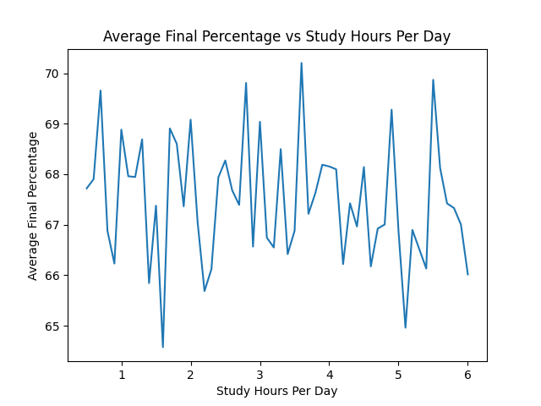

I grouped students by how many hours they study per day and plotted the average final percentage for each value. The line jumps up and down between about 65% and 70% and does not steadily rise as study hours increase. In this dataset, more study hours do not clearly mean a higher average grade.

Task 2
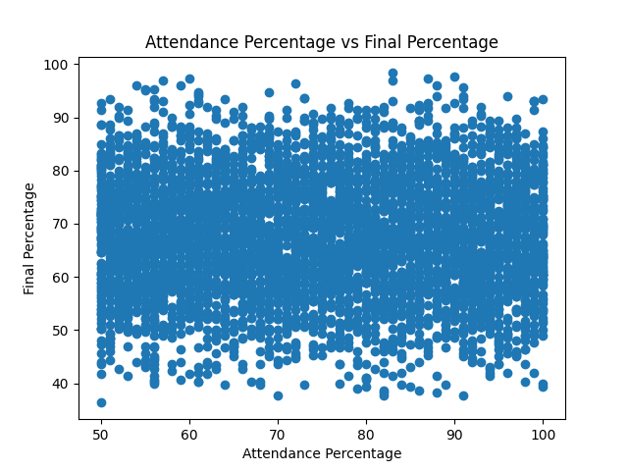

I made a scatter plot with one point per student. The points fill the whole chart with no upward or downward slope. Attendance and final percentage do not show a clear relationship here. The plot looks crowded because there are 5000 students, so many points overlap.

Task 3
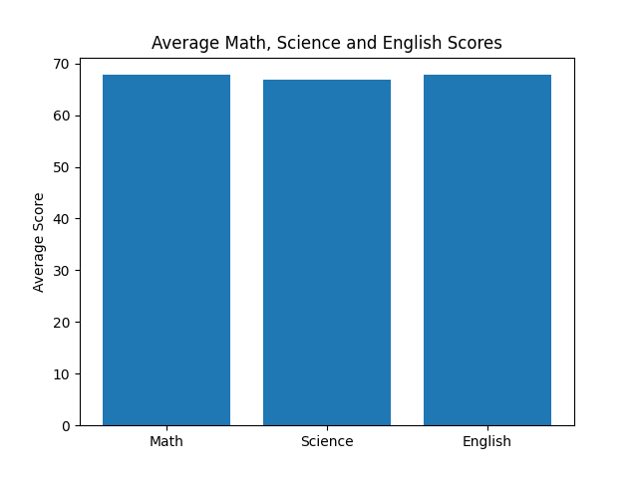

I calculated the average score for each subject and showed them as bars. The three averages are almost the same (around 67–68). Students in this dataset perform similarly in Math, Science and English.

Task 4

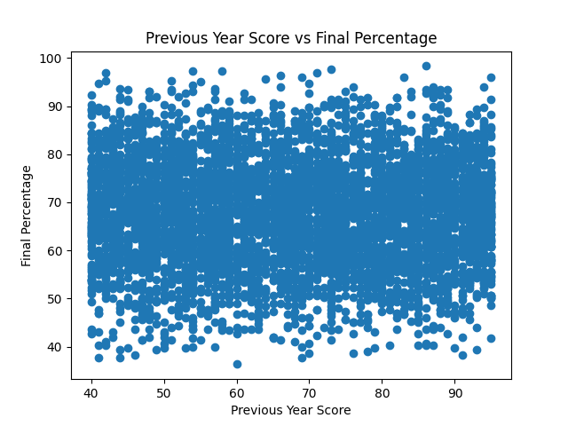

I plotted last year’s score against this year’s final percentage. The points are spread across the chart with no clear trend. A high score last year does not clearly go with a high final percentage in this dataset.

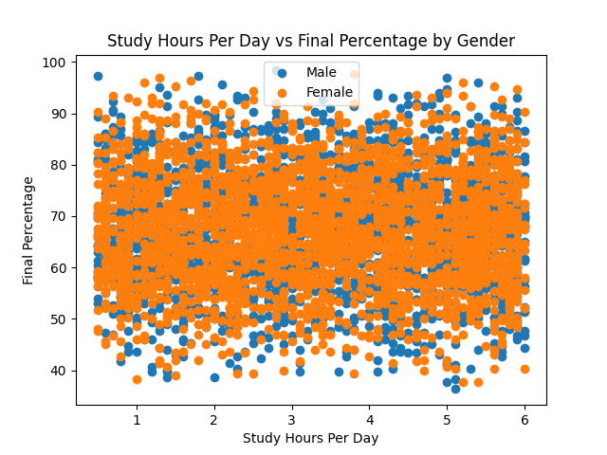
Task 5

Same scatter as study hours vs final grade, but male and female students are shown in different colours. Both groups are mixed all over the plot. There is no clear difference between genders, and still no clear link between study hours and final percentage.

Task 6
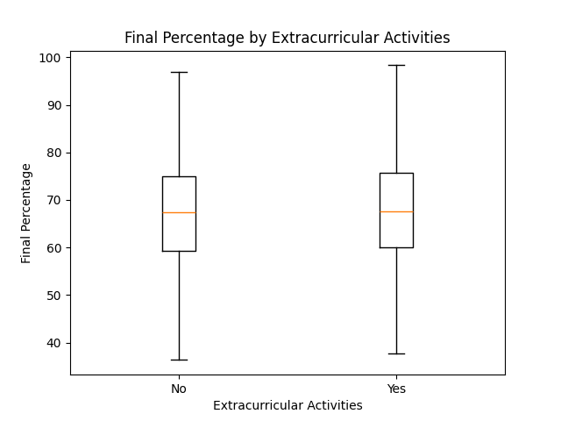

I used a box plot to compare students who do extracurricular activities with those who do not. The two boxes look almost the same (median around 67–68%). Joining extracurriculars does not seem to change final percentage much in this dataset.

Feature Selection
Feature selection was performed to identify which features in the dataset are relevant for predicting or analysing student performance. The dataset contains 16 features, but not all of them provide useful information for this purpose.
First, Student_ID was excluded because it is only a unique identifier for each student and does not contain information that can help explain academic performance. The features Performance_Level and Pass_Fail were also considered separately because they are outcomes derived from student performance rather than independent characteristics.
The remaining features were considered based on their potential relationship with Final_Percentage. Numerical features such as Study_Hours_Per_Day, Attendance_Percentage, Math_Score, Science_Score, English_Score and Previous_Year_Score are particularly relevant because they contain information that could potentially be related to the student's final performance.
Categorical features such as Gender, Class, Parental_Education, Internet_Access and Extracurricular_Activities were also retained because they can be useful when analysing differences between groups.
The feature selection helps reduce unnecessary information in the dataset and makes it easier to focus on the variables that are potentially relevant to student performance.

Code
The code I used to visualize the data can be found on my GitHub page here: https://github.com/Cybersecurity-Master/IAI4100-compolsory-assignment

